Amputee experiment at INAIL
Claudio Castellini
(for internal circulation only!)
experiment done on May 14th, 2008
report written on June 2nd, 2008

Introduction

Since the beginning of 2007, we have tried to check whether forearm surface electromyography (EMG) [1] could be used to classify the grasp/grip posture and, at the same time, guess the force involved, with the aim of improving the s.o.a. in active hand prostheses.
The work was, since the beginning, based upon machine learning, esp. Support Vector Machines [2]. It all began in January, 2007 within the project NEURObotics [3] at DLR (German Aerospace Research Center, Oberpfaffenhofen, Germany). We first tested it on a single healthy subject and in highly controlled conditions with good results [4,5]. We then showed that a robotic, non-prosthetic but highly dexterous hand could be actually controlled in real time using it [6].
Lately, the work has been carried on at IIT (Italian Institute of Technology, Genova, Italy) on multiple subjects and with freely moving arm and body with equally good results [7].
So, it was time to test it upon an amputee, in order to check whether it is really feasible, or it was “just” an academic exercise, possibly usable in human augmentation and telerobotics, but not in prosthetics. To this aim, at INAIL Centro protesi, Vigorso di Budrio (Bologna), on May 14th, 2008, a preliminary experiment on an amputee has taken place, in order to check the feasibility of the approach. This is a report about the experiment and preliminary analysis of the related data.
Notes, dangling references, current inaccuracies and so on are in red.

Materials and methods

Setup
Five OttoBock electrodes (Emanuele, what models are exactly the electrodes?) and a force sensor (I still have to list its characteristics… but it was similar to the SpaceControl thing we used at DLR) were connected to a NI-DAQ 6122 USB acquisition card, connected to my laptop (a kind of enrty level machine) equipped with National Instruments’ standard acquisition software SignalExpress.

The subject
The subject was Mr. Vincenzo, Italian, male, aged 63. Vincenzo was operated in faraway 1963 of a left-side trans-radial proximal amputation (Angelo and Emanuele: is this correct?) and was left with a stump about 8-9 cm. long. He has been using myoelectric prostheses since the mid-Sixties at least – he was actually a pioneer patient, and has been monitored by INAIL since then.
The electrodes were placed basically in the only possible way: uniformly spaced, around the stump; they were held in place by an elastic band. (A movie will shortly be available which will show everything in detail.)

Experiment description
The aim of the whole experiment was to assess whether it was possible to, at least,
- classify five grasping postures: (1) no action, (2) pointing index, (3) power grasp, (4) index pinch grip and (5) tripodal precision grip;
- understand how much force was involved in each grip/grasp, except for grip (2) which was assigned a predetermined force – it is an isometric/isotonic posture, used for pressing buttons.
We would then elicit each grip in turn from Vincenzo, with different grasp strengths and different grasp velocities. The experiment was organised, in turn, in three ways, which I will call, from now on, modalities:
- teacher imitation. A heatlhy teacher (Claudio) would place his left hand besides Vincenzo’s stump and hold the force sensor with his (hidden) right hand; he would then instruct the subject to contract his muscles as if to copy what the teacher was doing. The teacher would then assume, in turn, the five grasp postures, with resting time inbetween; and he would, at the same time, signal the periods of time when the subject was contracting his muscles by pressing the force sensor. Here the force sensor was used just as a switch; Vincenzo was instructed to contract his muscles with maximum tension.
- bilateral action. The subject would hold the force sensor in his right, heatlhy hand, and be instructed to “do the same” with both hands, including the modulation of force – that is, stronger grips with the right hand would correspond to stronger grips with the imagined hand. The sequence of actions and resting times was the same as in modality (1); Vincenzo, moreover, was asked to perform his grasping actions at first slowly, and then more quickly. This was done to test the system’s resilience to high-frequency movements.
- mirror box. According to Ramachandran [8], monolateral amputees enabled to see a fake hand superimposed to their missing hand, while imagining movements bilaterally, would report less ghost limb pain and better “management” of the ghost limb. In one case, the pain would completely disappear. It is then possible that a mirror box, that is, the simplest device which would reach such an effect, would ease the production of symmetric, bilateral movements. So we tried this one too. Unfortunately, the mirror box we had ordered in Britain [9] did not make it into Vigorso on time, so we simply interposed a mirror between the subject’s arms, and repeated the modality (2). Vincenzo really reported no feeling of improvement between modality (2) and this – it is actually known that mirror boxes require a rather long training to be effective, so perhaps this was too long a shot.
The whole experiment lasted less than half an hour. Vincenzo reported no fatigue, pain or stress (he was, actually, very kind and helpful throughout the whole experiment). The data were collected at 100Hz and saved on the laptop in a simple human-readable form: first column, a time index; second column, the output of the force sensor; third to seventh column, the output of the five electrodes.

Analysis

Data pre-processing
First of all, the question is: is 100Hz sampling rate too much, too little or ok? If it is too little (that is, force and/or EMG bandwidth much higher than, say, 150/200Hz) then we are hopeless and we have to redo the experiment. If it is too much, that is if the bandwidth is much lower than that, which I foresee, then we can happily subsample and reduce the number of samples, and consequently the training and testing time.
I gathered all the raw data in one big matrix (105600 samples @ 100Hz = some 17.6 minutes of activity), and then evaluated the power spectra:
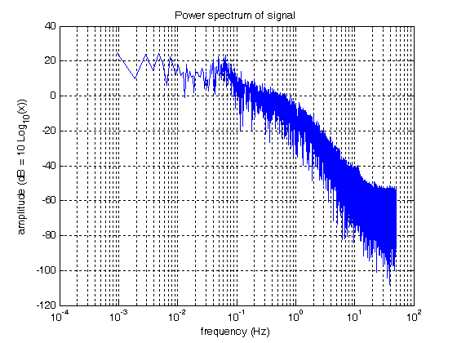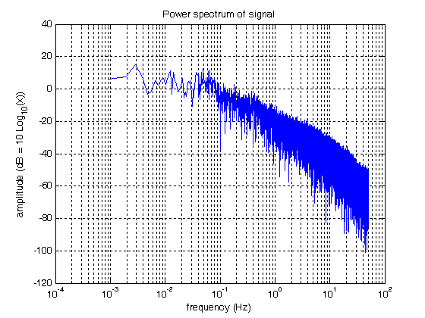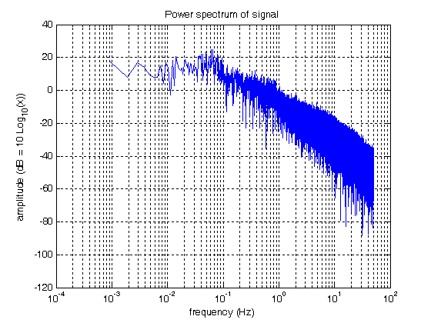
force, electrode 1, electrode 3 – the remaining electrodes are analogous to #1 and #3
As one can see, -30dB are reached at 2-3Hz (force), 10Hz (electrode 1) and 20-30Hz (electrode 3). This is quite in agreement with what we saw in Germany – OttoBock electrodes already perform an RMS filtering and therefore their output bandwidth won’t exceed the maximum speed at which a human subject can change his/her own muscular state, let us say 10Hz or something more.
I then decided to subsample everything at 25Hz, that is, to take one sample in four.

Further, I organised the analysis in three increasingly difficult – and interesting – “rounds”:
  - round I: I eliminated the fast grips by manual inspection (they are supposed to be harder to follow), plus I neglected grasp type (1), pointing index, therefore resorting to four categories.
  - round II: put the pointing index back in, getting to 5 categories.
  - round III: put the fast grips back in, too.
Negative values of the force sensor, that is, very low force signals, were labelled “category 0”, that is, no-movement.
Because of a technical problem, during bilateral action (modality 2) the pointing index was not recorded; we then used pointing index data coming from the teacher imitation modality (3) to make things uniform.
During the pointing index, in modalities (2) and (3), nobody was pressing the force sensor, so that we had to signal the grasp by checking when the first electrode would get above a small threshold. In that case we forced category #1 and a standard force value of 0.8.
All in all, just to see how the pre-processed data look like, here are three example plots from round III, the “full” round, modality (3) (force values have been multiplied by 3 in order for them to be clearly distinguished):
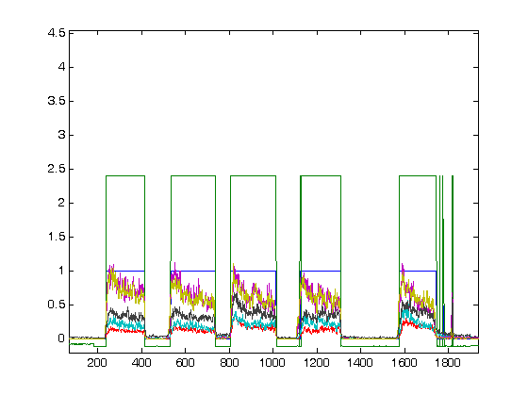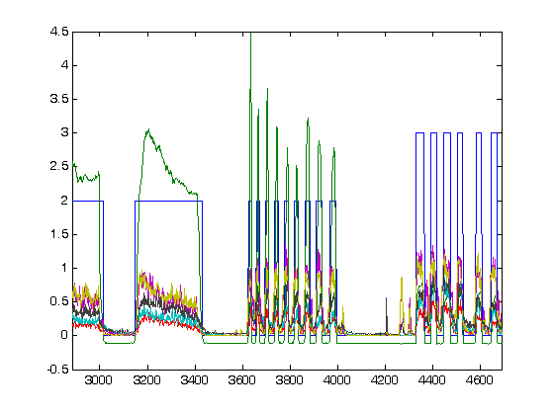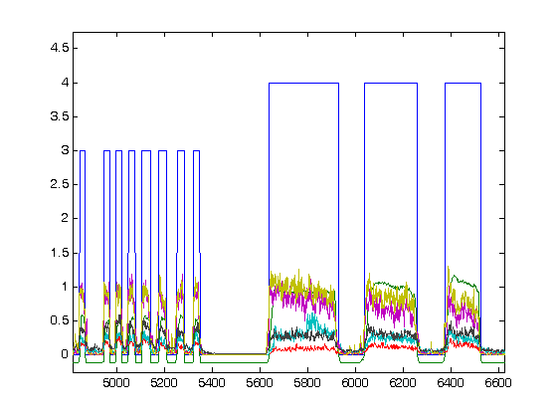
blue: category (0,1,2,3,4); green: force*3; other colours: EMG electrodes
In the first panel, the pointing index is visible, its category being 1 and its force being artificially set at 0.8*3=2.4. In the second panel, transition from power grasp slow grasps (category 2), to fast grasps, to pinch grip fast grasps (category 3). In the third panel, transition from pinch grip fast to tripodal slow (category 4). As one can see, the force values (green line) are way smaller during pinch and tripodal than during power grasp, as one would intuitively expect.

Dimensionality reduction
PCA reveals that the input data can be safely reduced to two dimensions, out of the original five ones. This is great news because we can now plot the samples and see how well separated they are. Here are the plots:
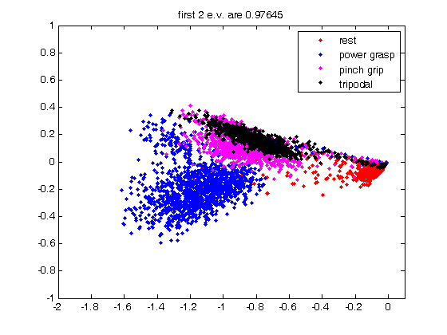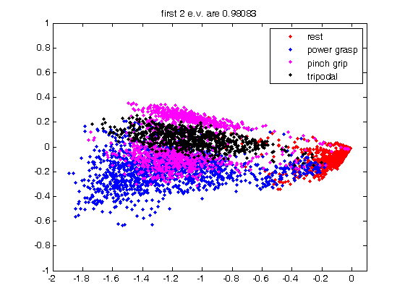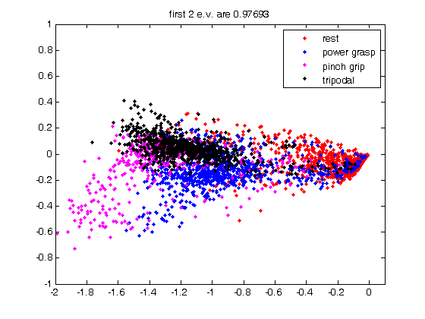
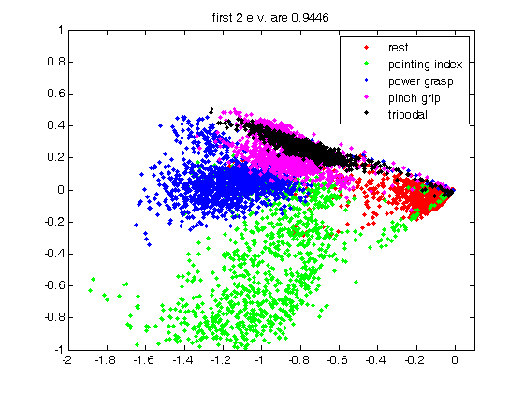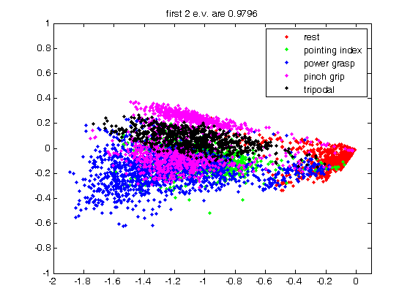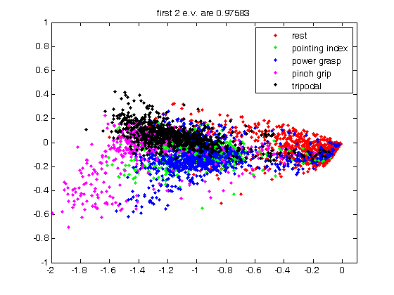
PCA plots. First row: round I, modalities 1/2/3; second row, round II (addition of category “pointing index”, in green), modalities 1/2/3
All in all the categories seem quite well separated, which lets us hope for the best; interestingly, things seem to get worse as we move from modality 1 (teacher) to modality 2 (bilateral) to modality 3 (mirror). Especially, category 1 (pointing index) is much more “shrunk” beneath the other categories in modalities 2 and 3. I have no explanation for this so far.
In fact, here is the classification/regression results for each round and modality:
 | Mod.1 (teacher) | Mod.2 (bilateral) | Mod.3 (mirror)
Round I (simple) | 89.4% / 0.95 | 88.0% / 0.93 | 83.0% / 0.91
Round II (w/cat.1) | 89.5% / 0.95 | 79.5% / 0.91 | 75.2% / 0.91
Round III (fast grips) | 89.6% / 0.95 | 76.4% / 0.91 | 72.3% / 0.90
classification and regression results. Classification accuracy is the average of ratios of correctly guessed labels; regression is the correlation coefficient betweeen the true and guessed force signal.
…which confirms it all. I find it surprising that regression is absolutely perfect regardless of the modality, whereas classification degrades as we add more problematic samples (round II and III), and this is ok, and as we use bilateral action and the mirror! (modalities (2) and (3)).
This seems to tell us that having a teacher to imitate is absolutely the best way of training the system. In this case the patient is giving us no indication of the involved force, so that regression has to be done upon what the teacher is doing; but we could as well train the classifier in the teacher modality, and later on train the regresson in bilateral modality.

Conclusions
It seems to work fine! And I personally find it incredible that Mr. Vincenzo, some fortyfive years after the operation, can still contract his stump muscles in such precise ways. Consider the PCA plots, round II, modality (1): the subject lets us clearly see which one is which, even by simple visual inspection! The subject is even able to generate two clearly distinct signals for two quite similar grips, category 3 (pinch grip with index and thumb, in magenta) and 4 (tripodal grip, using thumb, index and middle, in black).
Lastly, here goes two examples of classification and regression signals, in order to visually check them. Notice how classes 3 and 4 get pretty messed up with each other, as expected, but they are, most likely, usable. As far as regression is concerned, please notice that we are heading for correlation between guessed and true values, rather than minimizing the mean square error. This is because a prosthesis will hardly be able to reproduce a human hand’s force, if only for safety reasons; therefore, we are more interested in generating a signal which is as proportional as possible to the original one.
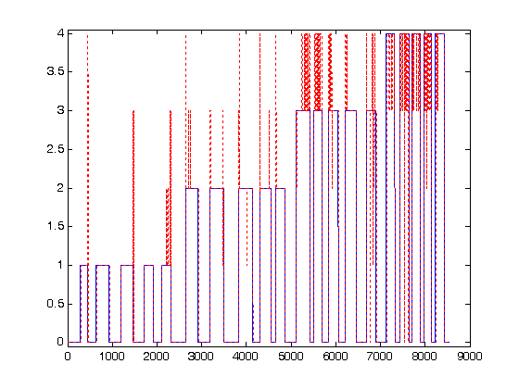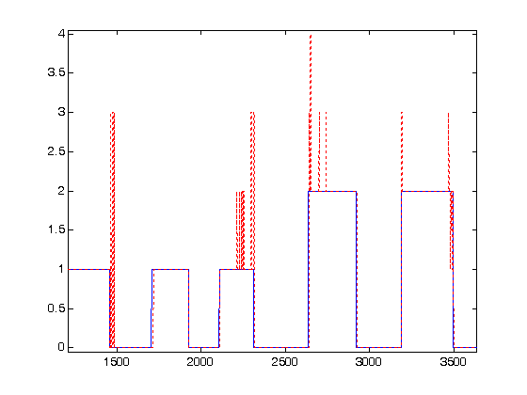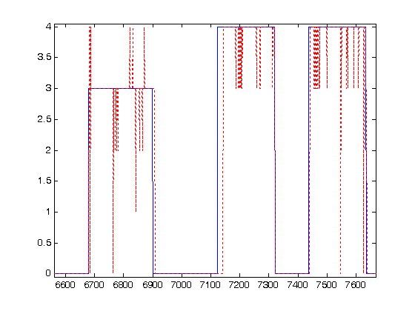
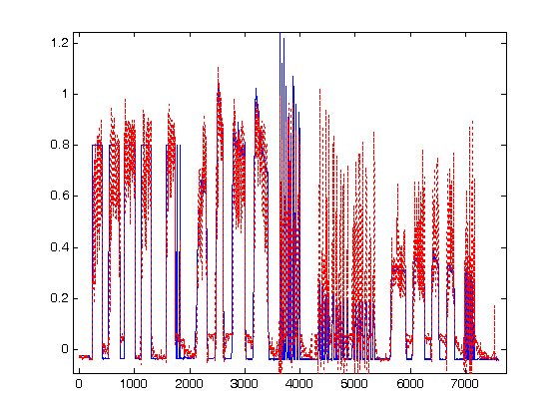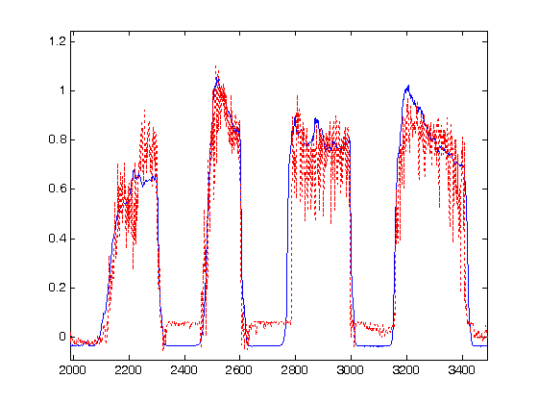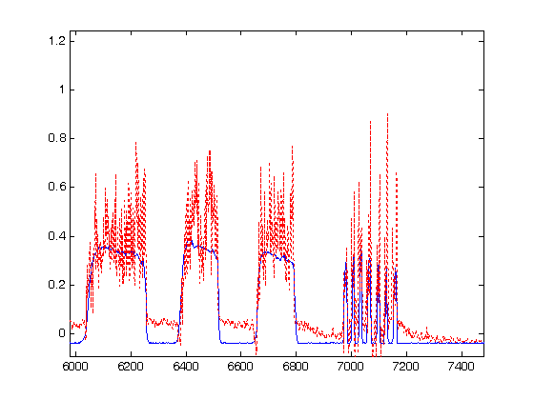
True values (blue) vs. guessed values (red dotted). First row: classification, i.e., grasp type – note how classes 3 and 4 get frequently messed up. Second row: regression, i.e., grasp force.
Bibliography
[1] Carlo J. De Luca, 2001. Very general reference on EMG.
[2] Boser, Guyon, Vapnik, COLT 1992. Seminal paper, the birth of SVMs.
[3] http://www.neurobotics.org
[4] Castellini, van der Smagt, Hirzinger, Sandini, ICRA 2008.
[5] Castellini, van der Smagt, Biological Cybernetics 2008.
[6] On Claudio’s web page, http://people.liralab.it/drwho , a movie can be found which shows the hand, controlled in real time by the system. By the way: this EMG thing is making it to the press! Check the “on the press” link on the web page…
[7] Castellini, Fiorilla, Sandini, poster at the 1st congress of the Italian Bioengineerings Group.
[8] Ramachandran 1995, the mirror box paper.
[9] http://www.

This does not mean that two electrode would actually suffice; the PCA transformation matrix shows more-or-less uniform coefficients. For example, in the case of round I, modality (1), the first plot in the above Figure, the 5x2 matrix applied to the 5 electrode values to get the 2 visible coordinates is: [[-0.1298 -0.2233 -0.6289 -0.6799 -0.2749] [-0.4075 -0.5398 0.0145 0.4706 -0.5664]]. As one can see, the transformed coordinates contain contributions from each of the original five electrode values, uniformly weigthed.

